## Overview

In this activity, you will continue building a landing page for the Casa Royal Real Estate Company.  
  
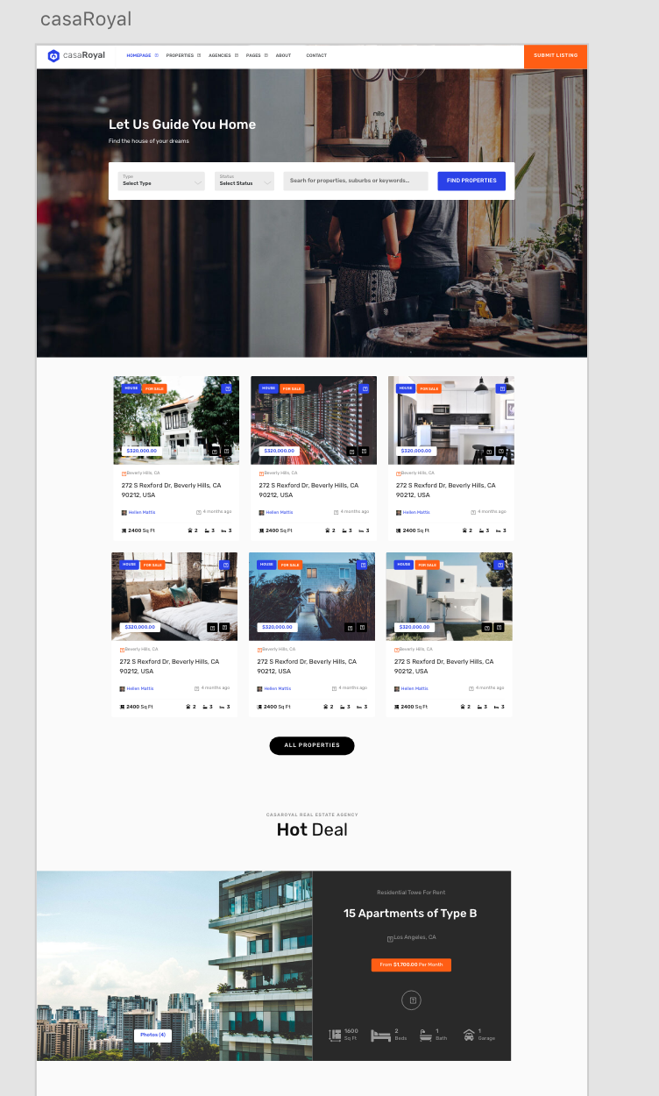

## Instructions

1. If you opt for option 1:
   1. Go review the homework instructions for **Unit 20**.
2. If you opt for option 2, download the Adobe XD file from the Activities folder.
   1. 
3. In the top-right hand corner of XD click SHARE > SHARE FOR DEVELOPMENT.
   1. 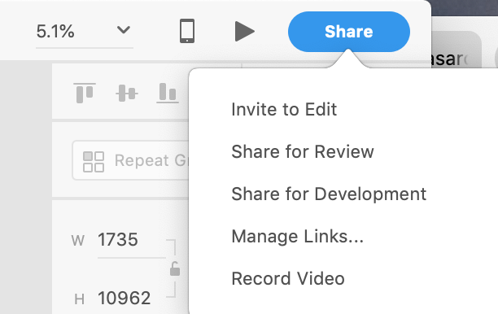
   2. Open the link in the browser. Use the developer mode to inspect the mockup so you can build the mockup in Webflow according to the correct dimensions.
      1. Create the landing page section first.

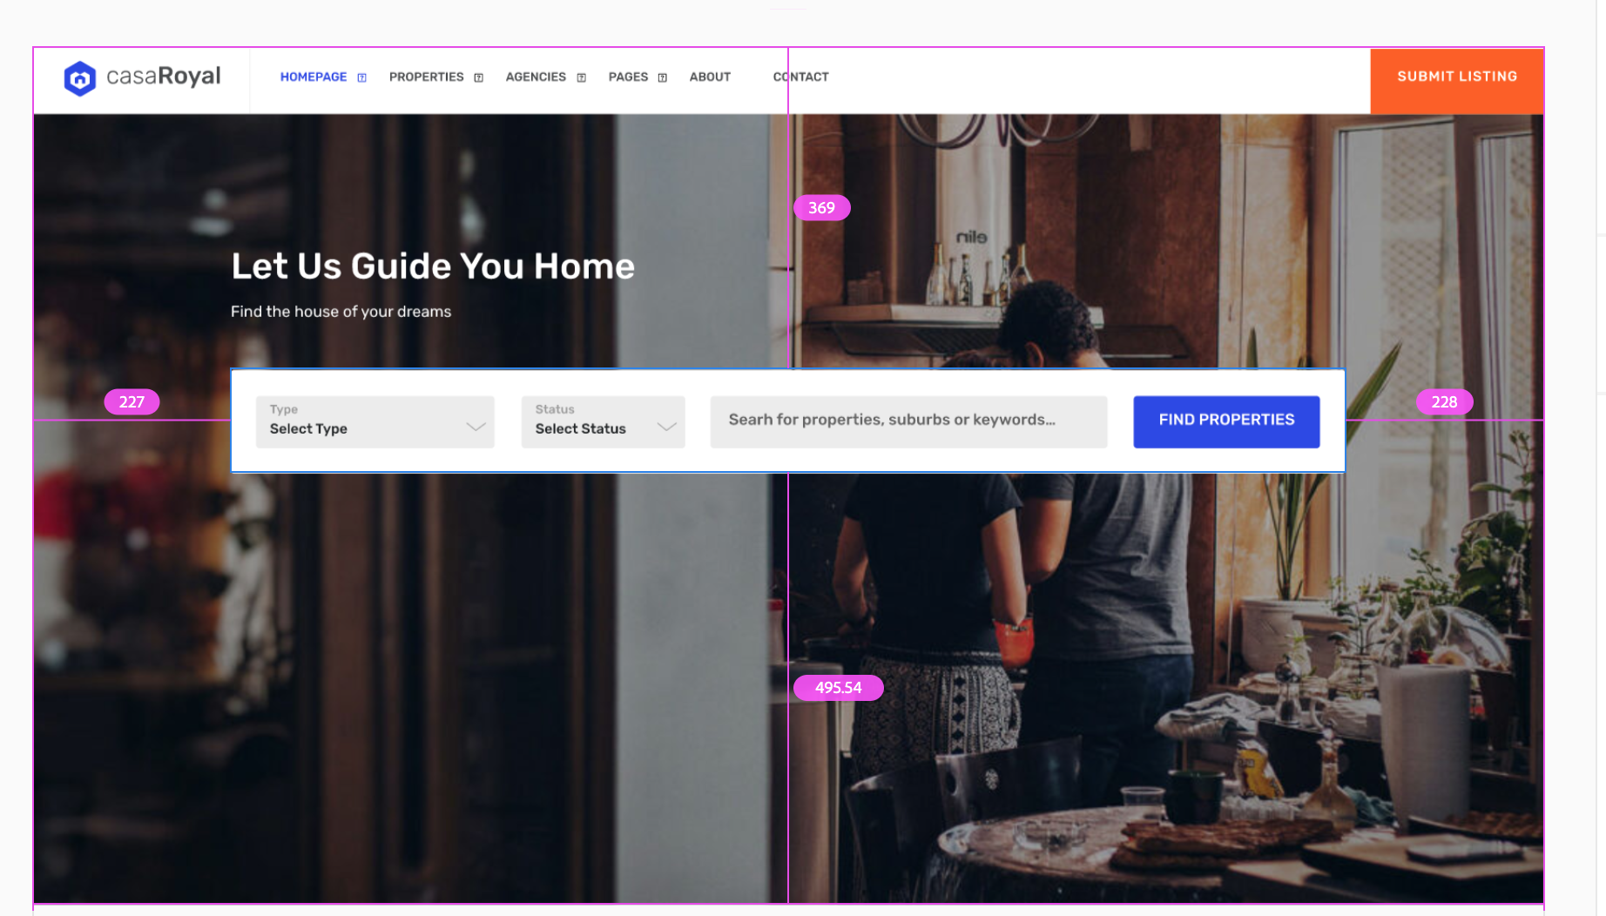

1. Use the Grid in webflow to create a 2x3 grid.

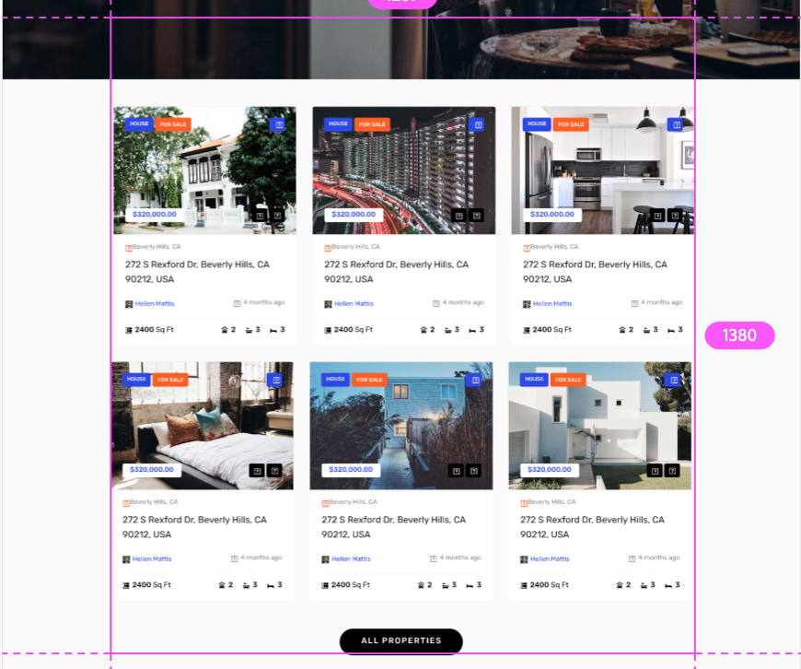

1. Create a section for the apartment listing

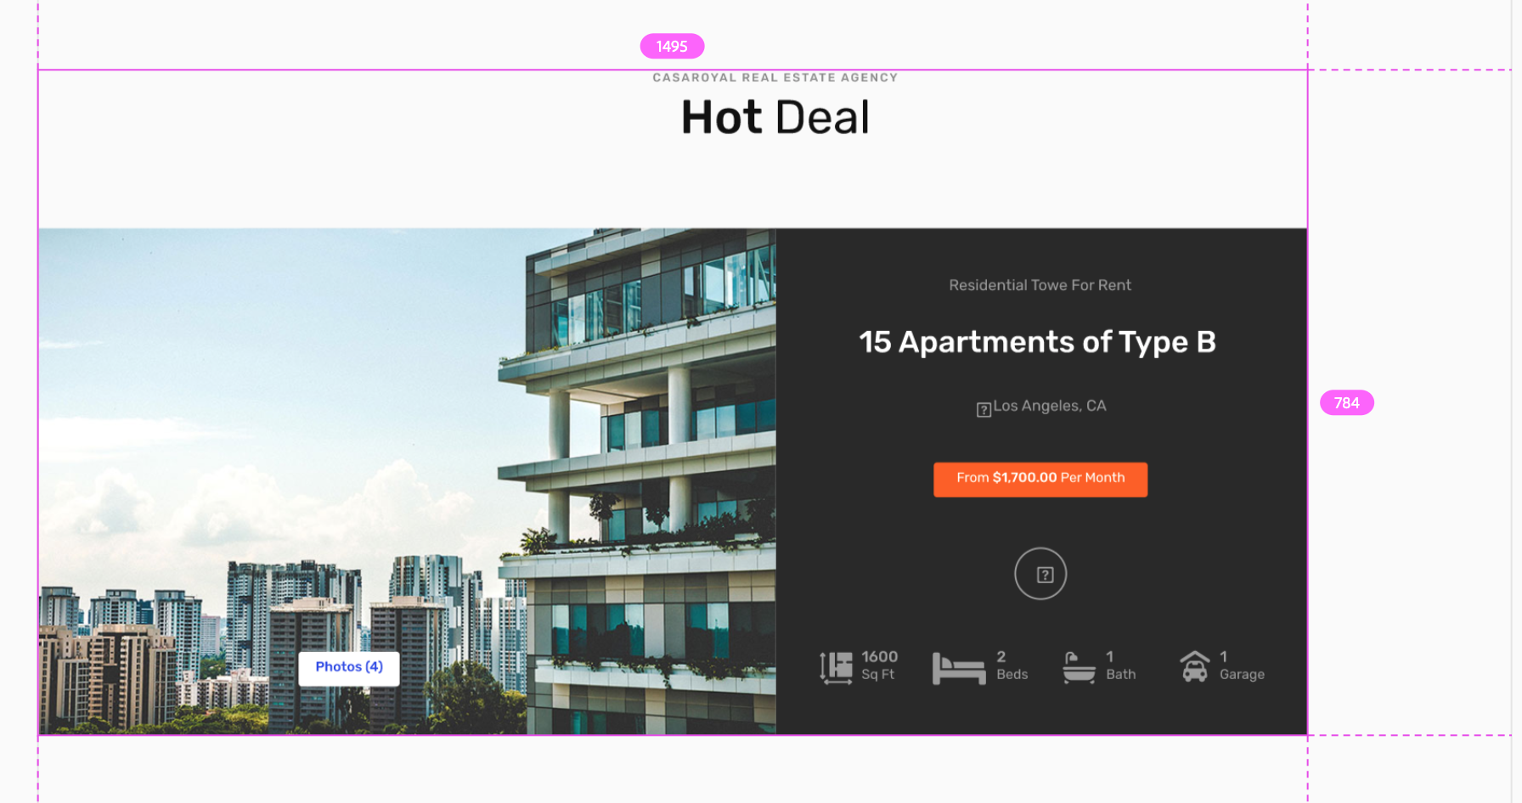

1. Create a 2x3 grid section. Create 2 grid areas within the grid.

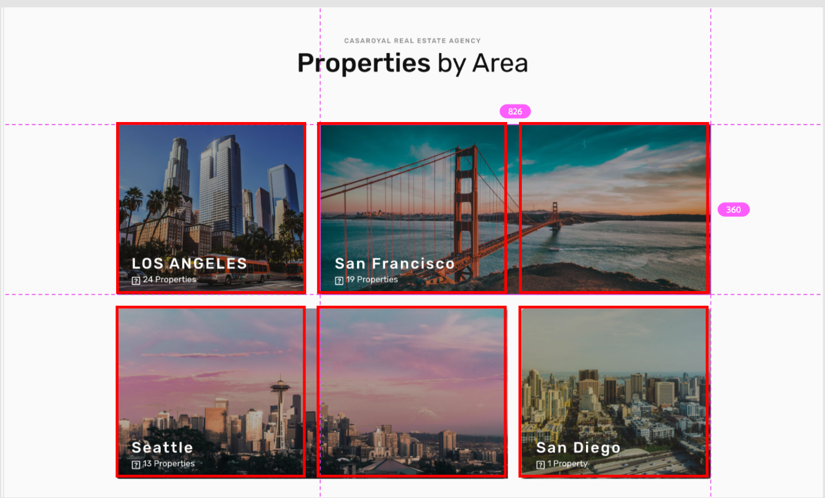

1. Create a section with a 3-column layout for the agents.

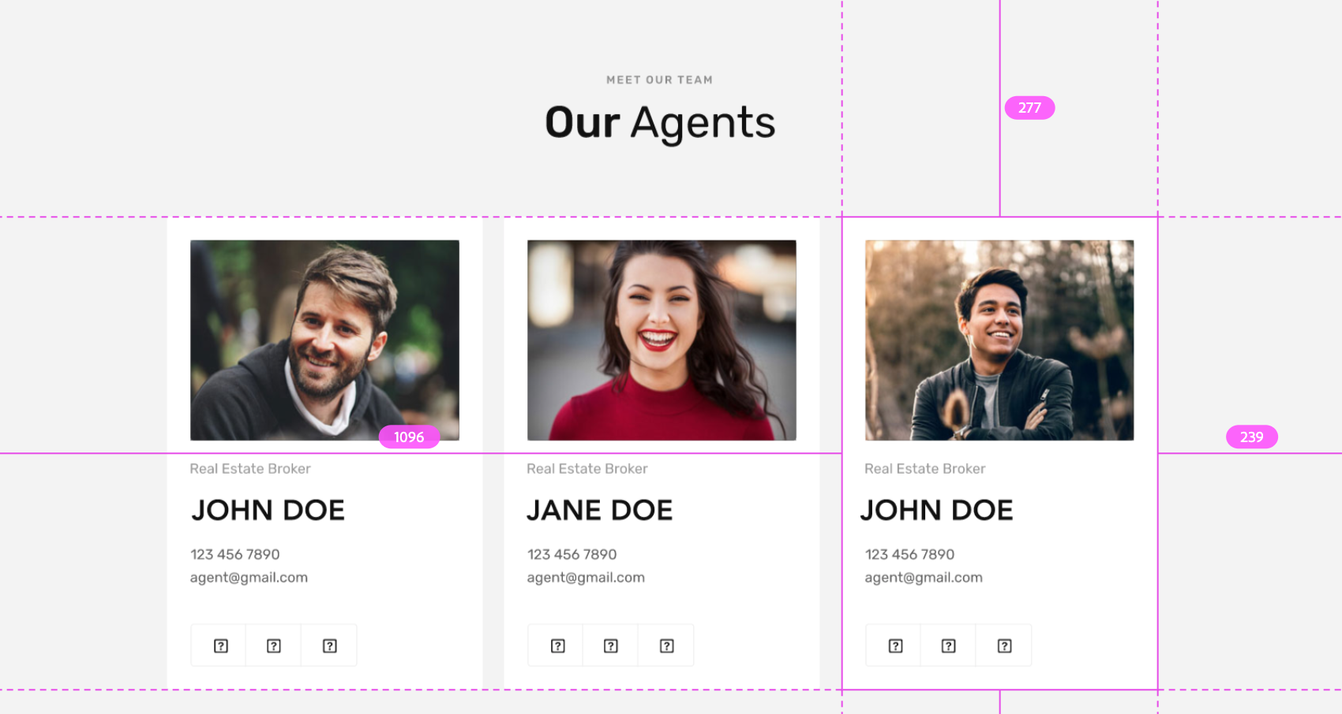

1. Create a section. Add a background image to the section. Add a container within the section.

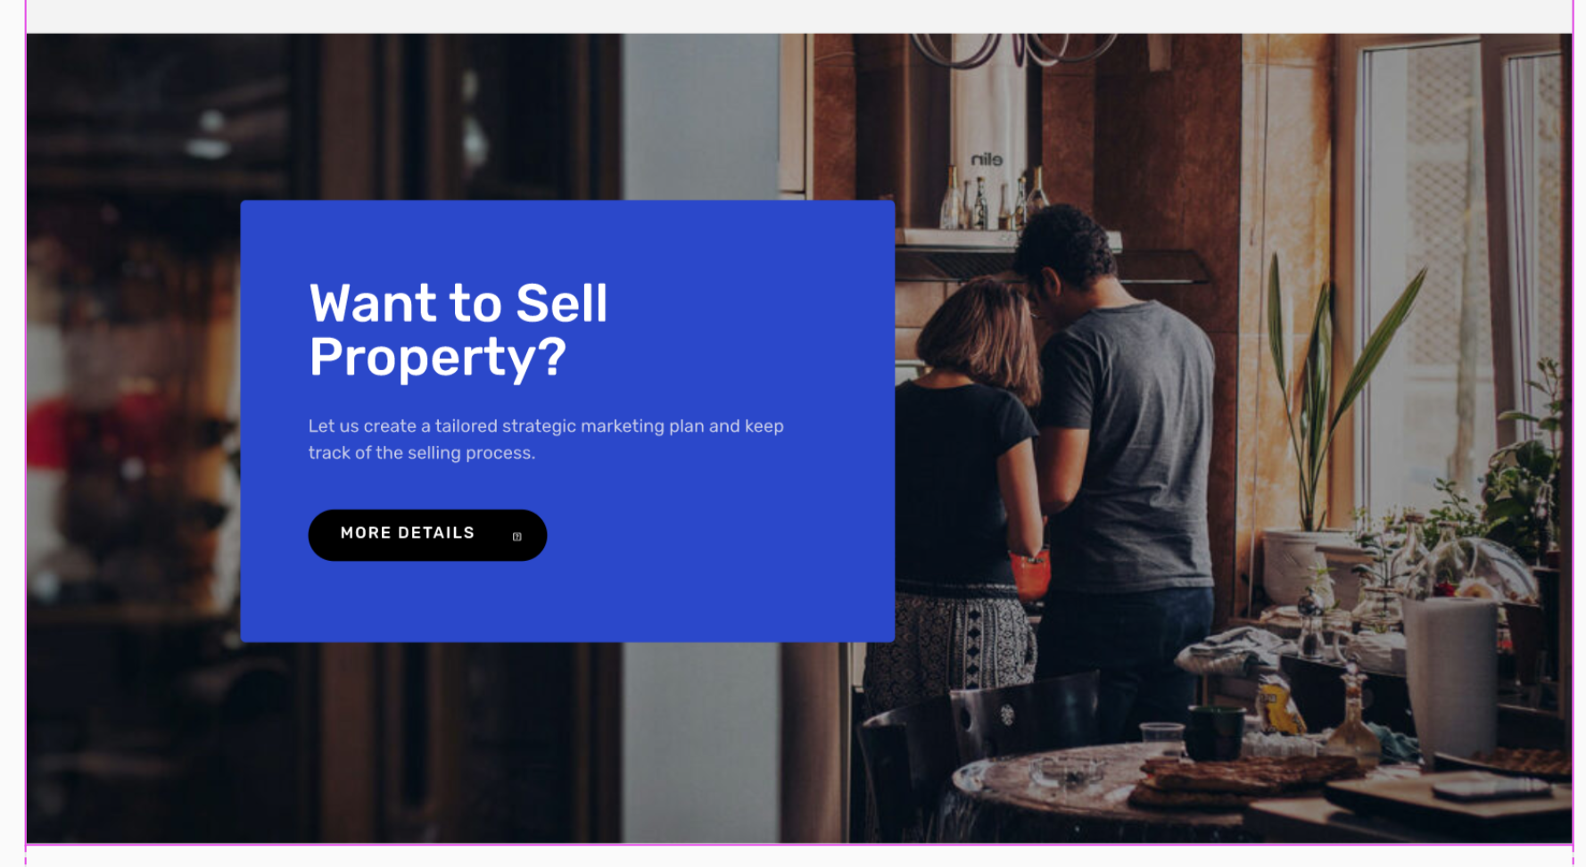

1. Create a section with a 3-column layout.

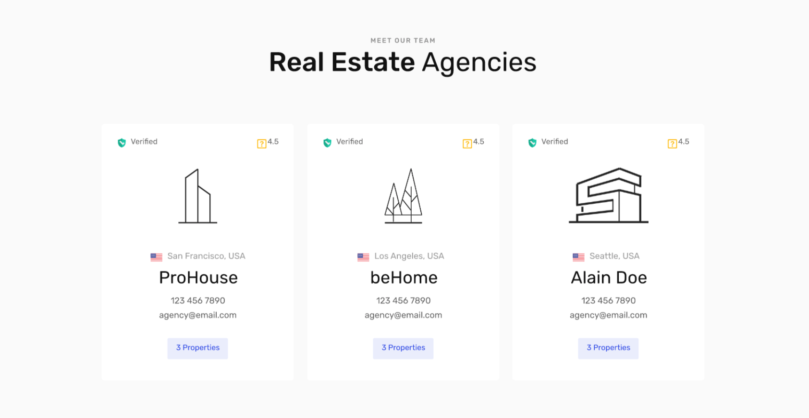

1. Create a section with a 3-column layout.

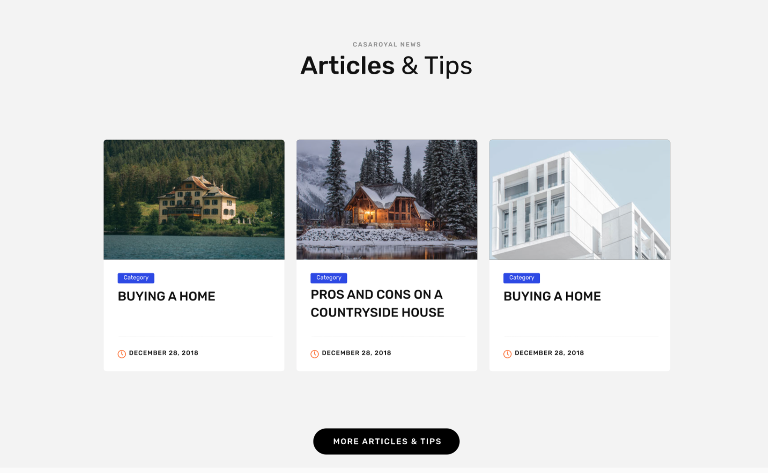

1. Create a section with a 3-column layout.

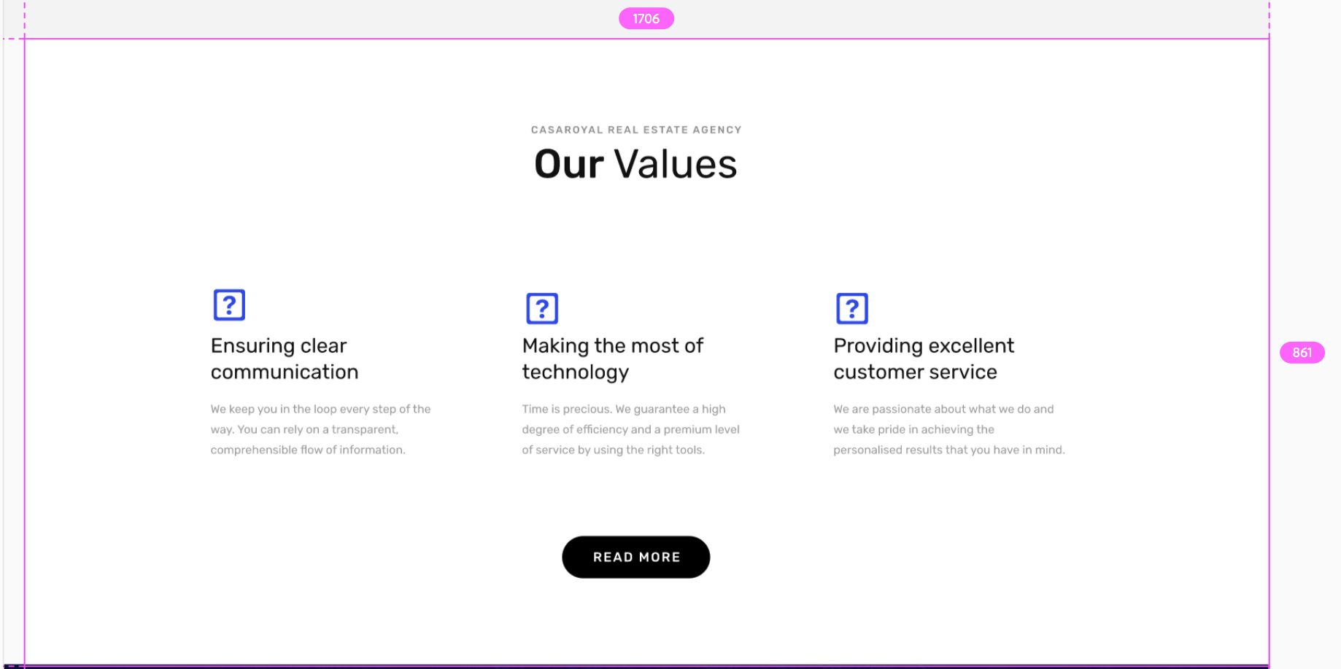

1. Create a section with a slider.

# 

1. Create a footer section with a 5 column layout.

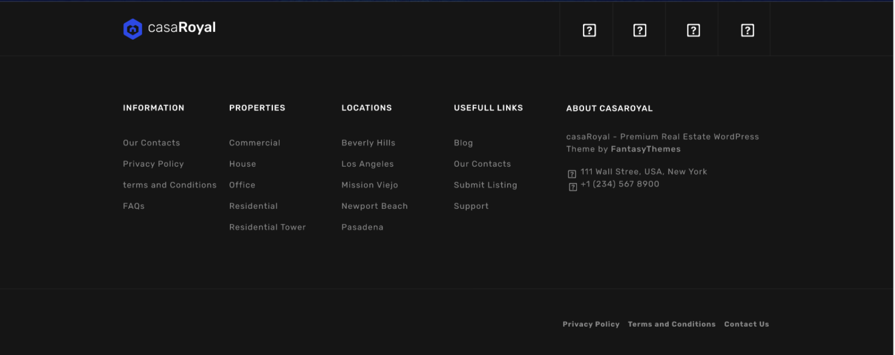

1. That's it! Take a minute to check out what you accomplished!